Bengston Energy Healing Method® Workshop

You will be learning to “charge” both cotton and water during the upcoming workshop. Since you will be attending from home, we need you to have cotton and water on hand for these exercises.

Below you will find a list of places that you can purchase cotton. Purchasing a large quantity of cotton is quite inexpensive. Regardless of the quantity purchased, please cut a piece of cotton that is approximately three inches by six inches (3”X6”) and have ready for the charging exercise.

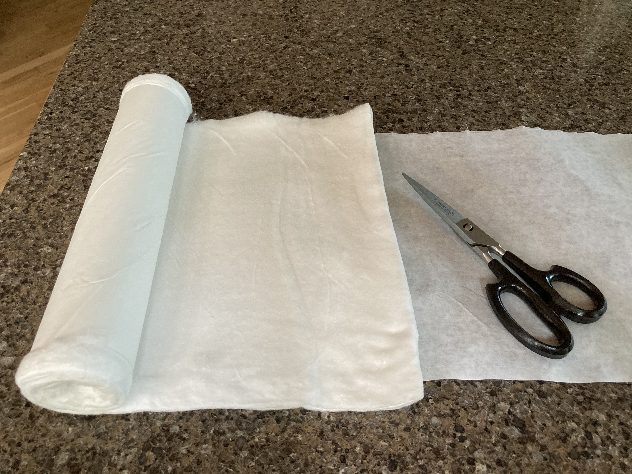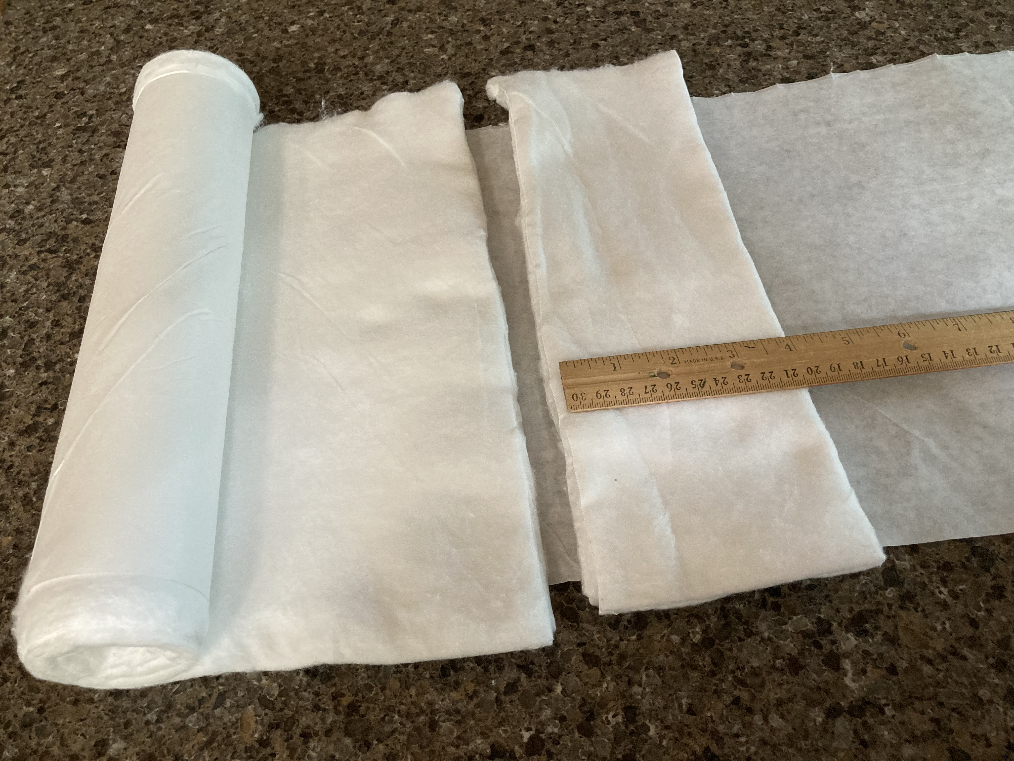

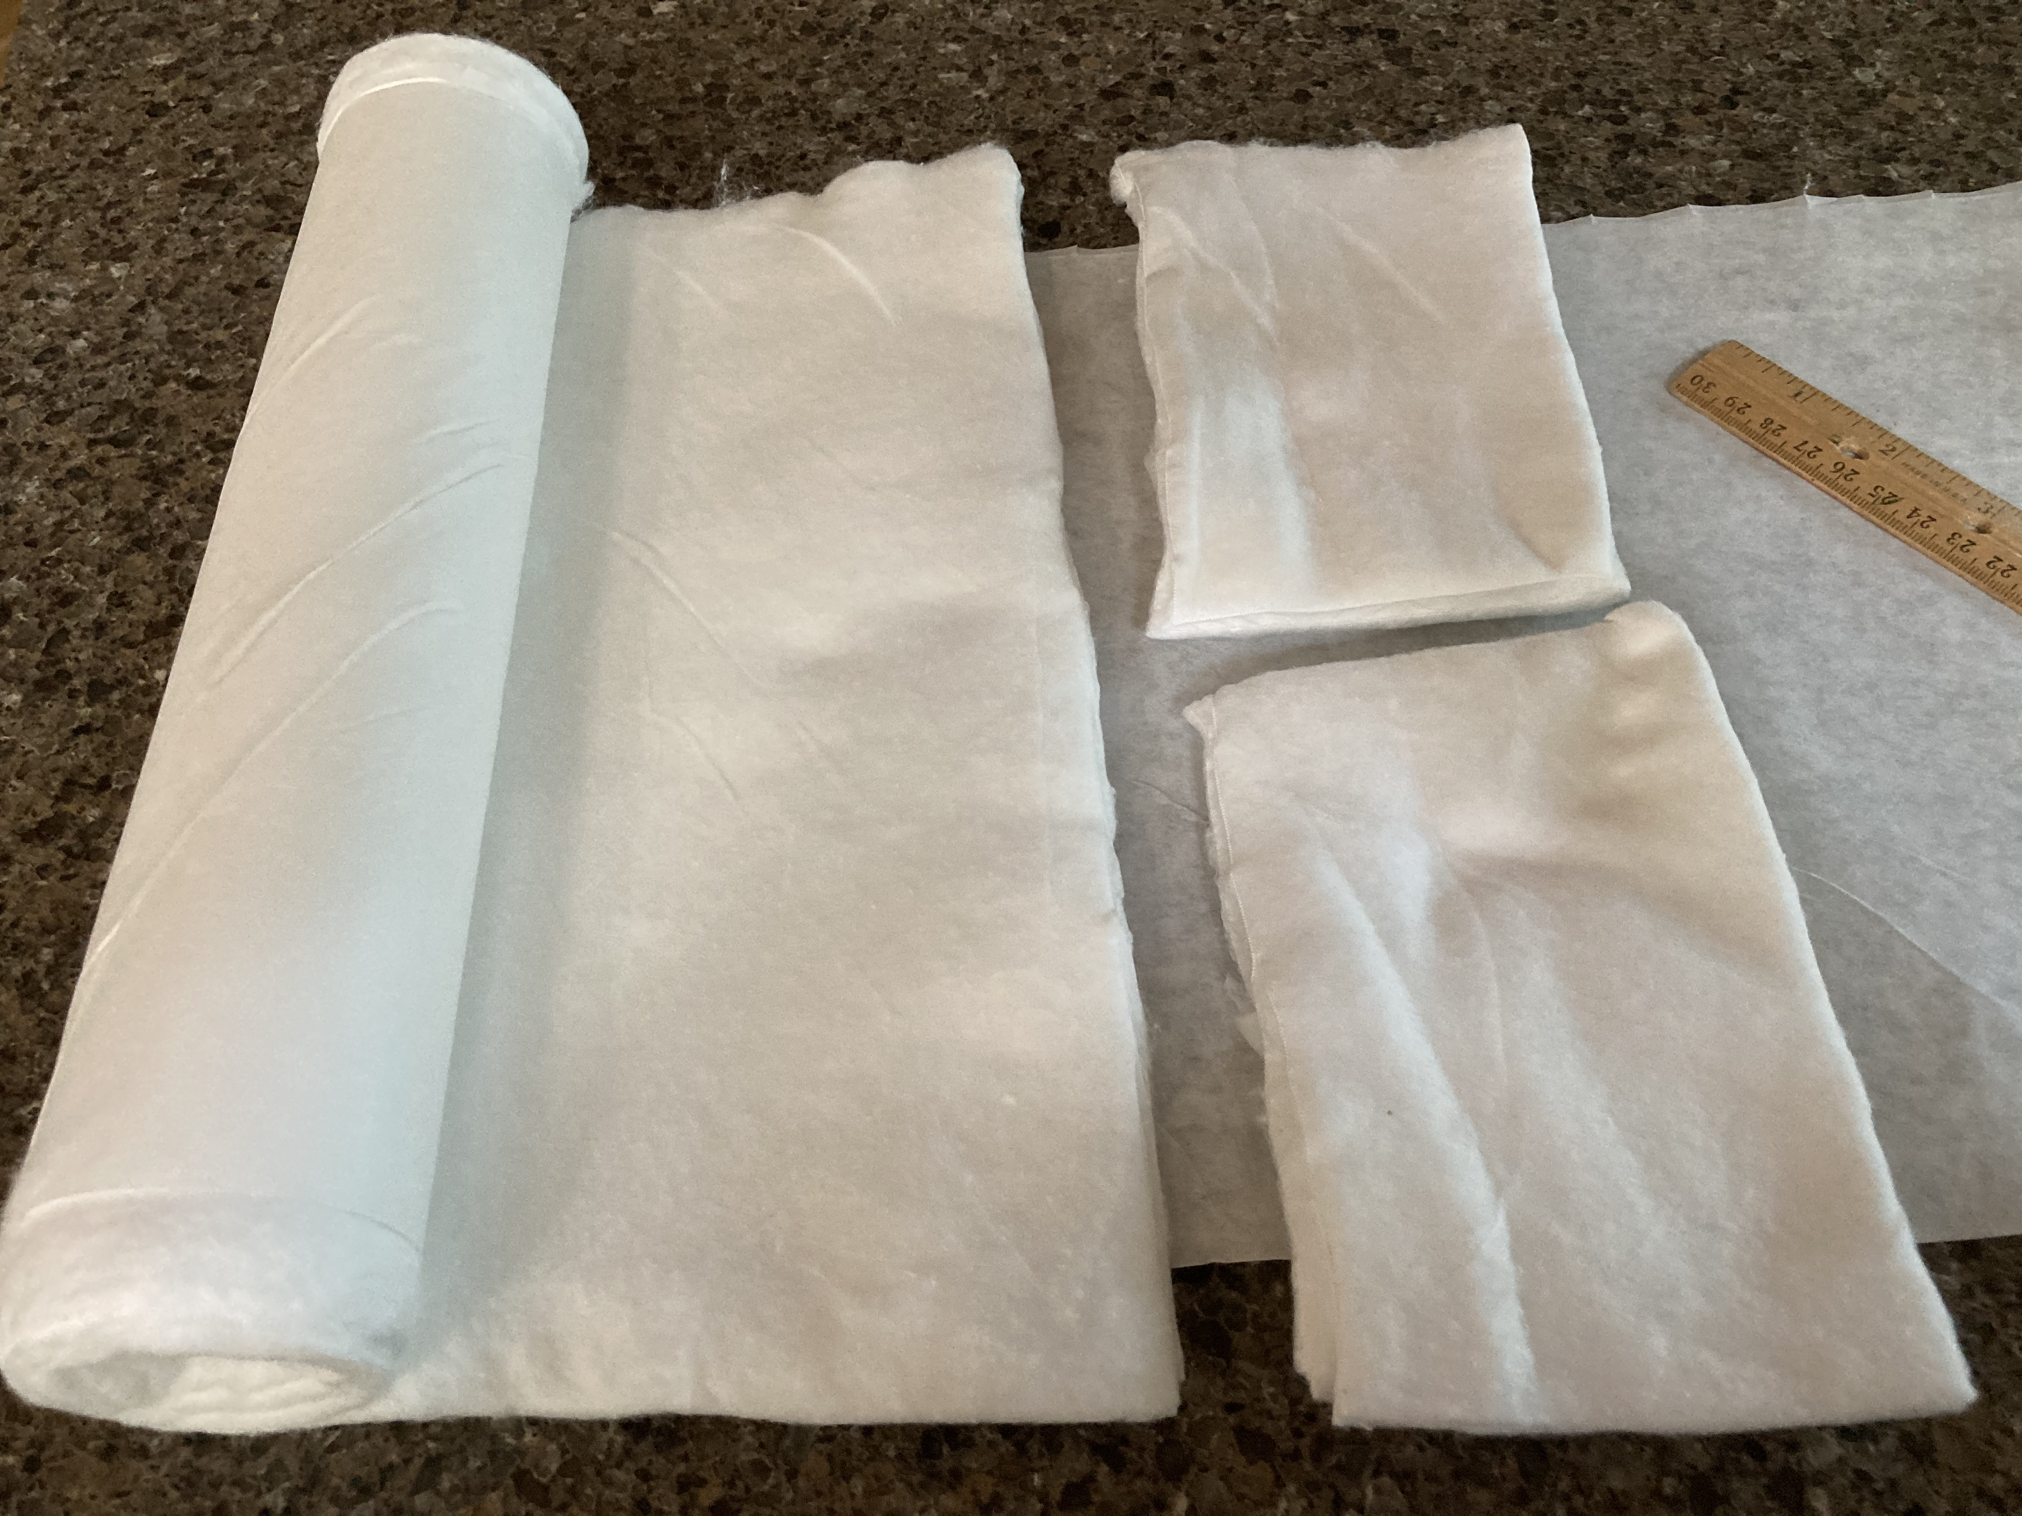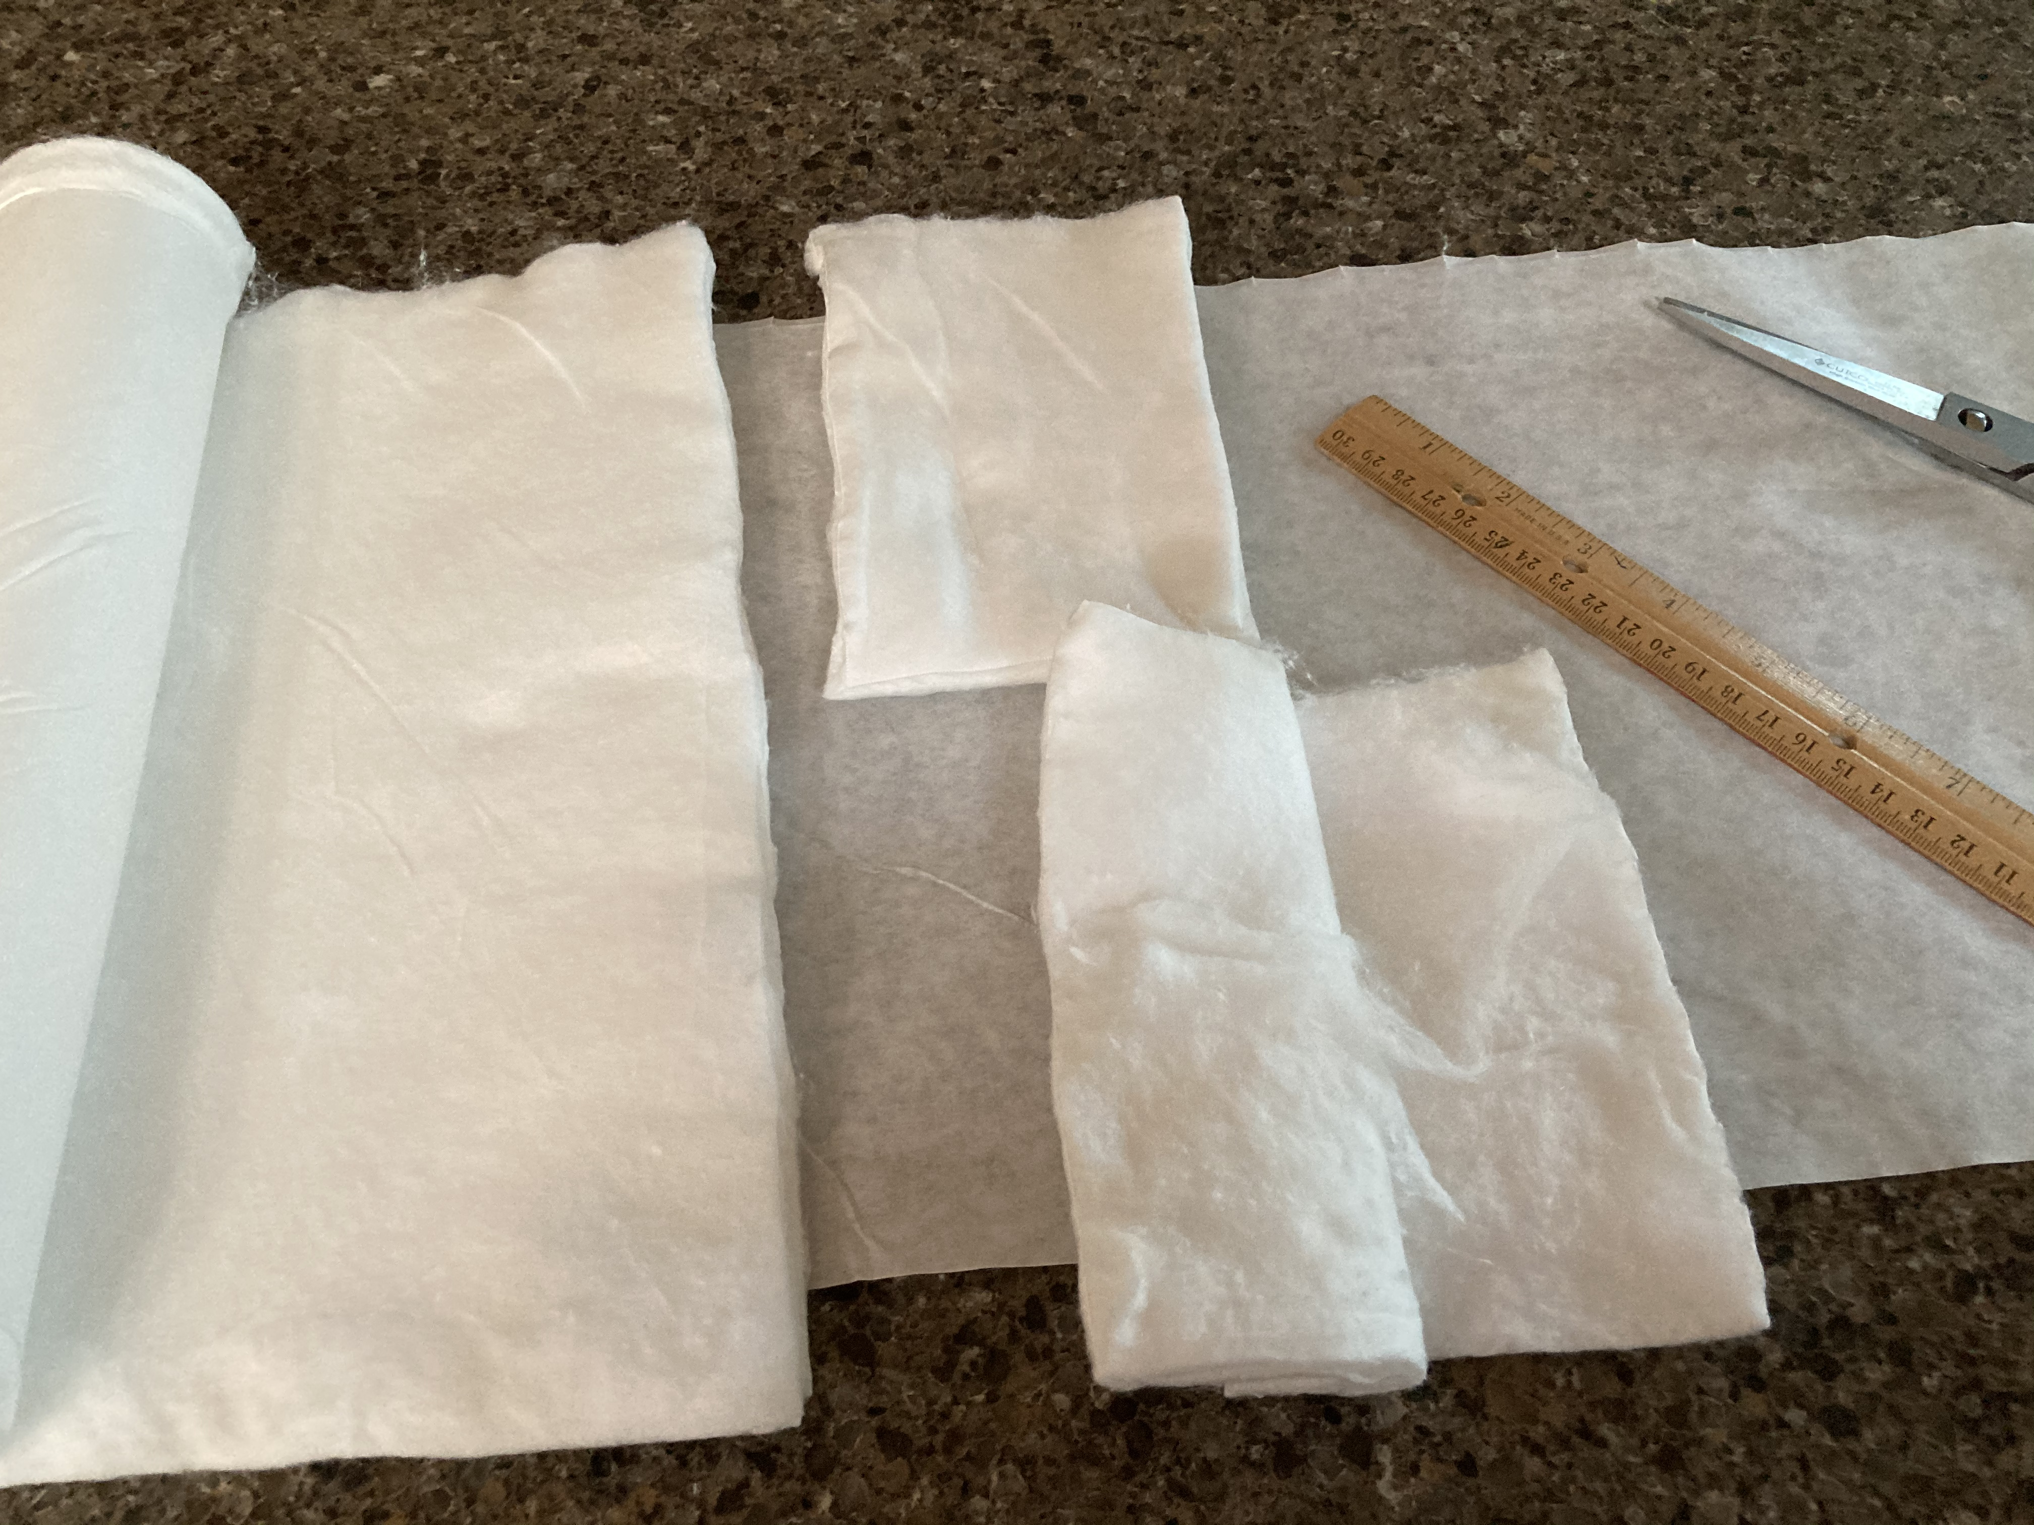

For charging water, you can use tap water or bottled water. It doesn’t matter if the bottle is plastic or glass. We do not recommend distilled water. Having some minerals in the water seems to be best. Please have a small amount of water, about one or two cups, ready for this exercise.

Where to purchase cotton.
The cotton does not have to be sterile. If you are searching for cotton on the internet it is typically called “rolled cotton.” Cotton balls or pads used for cosmetic purposes that not 100% cotton do not seem to charge.

Several cotton sources are below:

- CVS or Rite Aid online (some store locations carry it, but not all) - runs about $5 for a 4.76 oz box. This can be difficult to cut.
- Walgreens - Padco – 1 lb for about $10.00.
- Massagewarehouse.com – Intrinsics 1 lb cotton roll, both regular and not organic $6.00 - $10.00
- Amazon sells cotton by the pound and offers many brands, including Padco, both non-sterile, sterile and organic.
- In Europe ZigZag cotton can be found in most pharmacies or online at https://www.ecco-verde.com/masmi/organic-cotton-zigzag

